Class Topic on 05th April, 2025

Title/Journal Case | Periodic |  | Perpetual
 | Buyer/Purchase | Seller/Sales | Buyer/Purchase | Seller/Sales
Purchase/Sells | Purchase Dr.  Accounts Payable Cr. | Accounts Receivable Dr.  Sales Revenue | Inventory Dr.  Accounts Payable Cr. | Accounts Receivable Dr.  Sales Revenue Cr.  Cost of goods sold Dr.  Inventory Cr.
Purchase and Sales Returns | Accounts Payable Dr.  Purchase Ret & All. Cr. | Sales Ret & All. Dr.  Accounts Rece. Cr. | Accounts Payable Dr.  Inventory Cr. | Sales Ret & All. Dr.  Accounts Rece. Cr.  Inventory Dr.  Cost of goods sold Cr.
FOB Shipping Point (Buyer)  FOB Destination (Seller) | Fright in Dr.  Cash Cr. | Fright Out exp Dr.  Cash Cr. | Inventory Dr.  Cash Cr. | Fright Out exp Dr.  Cash Cr.
Payment Received and Paid with Discount  2/10, Net 30 (2% Discount if payment is made within 10 days) | Accounts Payable Dr.  Cash Cr.  Purchase Disc. Cr. | Cash Dr.  Sales Disc. Dr.  Accounts Rece. Cr. | Accounts Payable Dr.  Cash Cr.  Inventory Cr. | Cash Dr.  Sales Disc. Dr.  Accounts Rece. Cr.

P5.4A

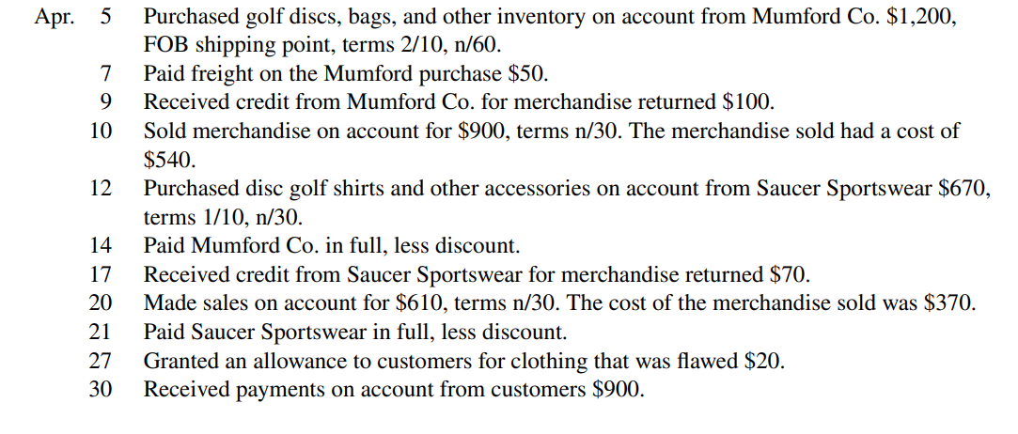
5. Inventory Dr. 1200  A/Payable Cr. 1200 | 14. A/Payable Dr. (1200-100) 1100  Inventory Cr. 22  Cash Cr. 1078
7. Inventory Dr. 50  Cash Cr. 50. | 17. A/Payable Dr. 70  Inventory Cr. 70
9. A/Payable Dr. 100  Inventory Cr. 100 | 20. A/Receivable Dr. 610  Sales Revenue Cr. 610  Cost of goods sold Dr. 370  Inventory Cr. 370
10. A/Receivable Dr. 900  Sales Revenue Cr. 900  Cost of goods sold Dr. 540  Inventory Cr. 540 | 21. A/Payable Dr. (670-70) 600  Inventory Cr. 6  Cash Cr. 594
12. Inventory Dr. 670  A/Payable Cr. 670 | 27. Sales Return and Allowance Dr. 20  A/Receivables Cr. 20
29. Cash Dr. 900
A/Receivables Cr. 900

P5.2A
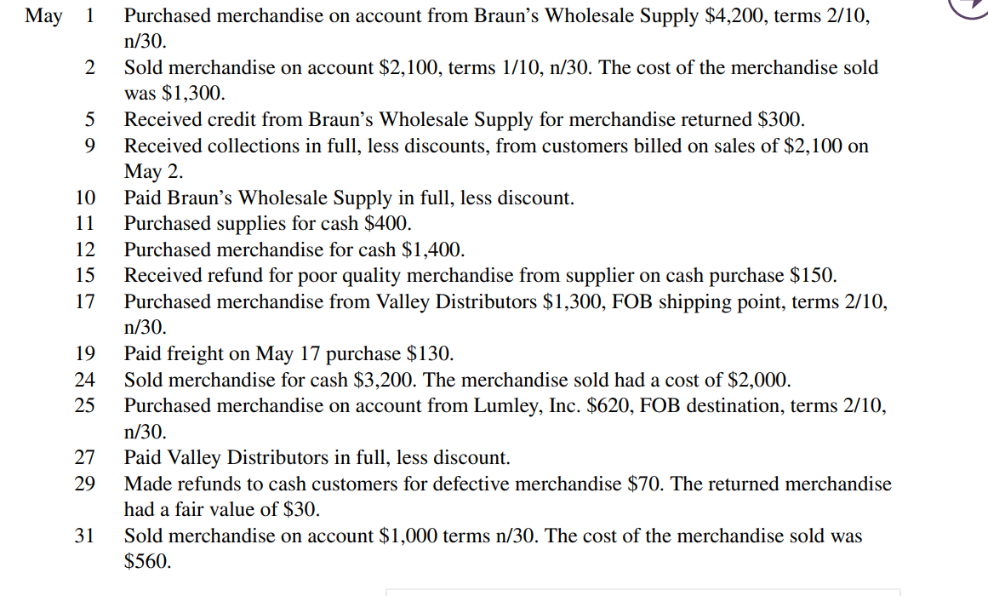
- Inventory Dr. 4200  A/Payable Cr. 4200 | - A/Receivable Dr. 2100  Sales Revenue Cr. 2100  Cost of the goods sold Dr. 1300  Inventory Cr. 1300
5. A/Payable Dr. 300  Inventory Cr. 300 | 9. Cash Dr. 2058  Sales Discount Dr. 42  A/Receivable Cr. 2100  (2100*2%= 42)
11. Supplies Dr. 400  Cash Cr. 400 | 12. Inventory Dr. 1400  Cash Cr. 1400
15. Cash Dr. 150  Inventory Cr. 150 | 17. Inventory Dr. 1300  A/Payable Cr. 1300
19. Inventory Dr. 130  Cash Cr. 130 | 24. Cash Dr. 3200  Sales Revenue Cr. 3200  Cost of the goods sold Dr. 2000  Inventory Cr. 2000
25. Inventory Dr. 620  A/Payable Cr. 620 | 27. A/Payable Dr. 1300  Inventory Cr. 26  Cash Cr. 1274
29. Sales Return and Allowance 70  Cash Cr. 70  Inventory Dr. 30  Cost of the goods sold Cr. 30 | 31. A/Receivable Dr. 1000  Sales Revenue Cr. 1000  Cost of the goods sold Dr. 560  Inventory Cr. 560

